**Application form for admission to the Preparatory School**

Registration

To log in for accessing the application form a prospective student of the Preparatory School should follow the link: <https://shelly.kpfu.ru/e-ksu/portal_podfak_site.login> (choose the “Registration”/ «Регистрация» button).

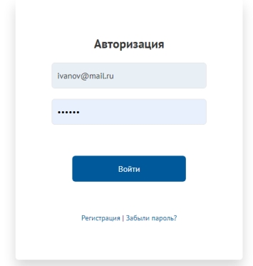

The registration form shall be accordingly completed, all the sections marked with an asterisk* being mandatory. It is possible to choose the language (Rus/Eng) of the registration form.

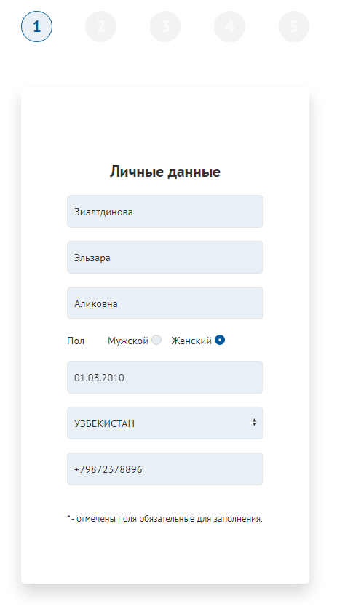

The applicant should click the “Save”/ «Сохранить» button after filling in the registration form.

The applicant will get an e-mail from [noreply@kpfu.ru](mailto:noreply@kpfu.ru) for the registration confirmation. In case there is no confirmation e-mail in the “Inbox” folder, it is recommended to check “Spam” folder of the e-mail box. The e-mail shall contain instructions for finishing the registration procedure. The user is to follow the link that is in the e-mail.

In the pop-up window the user is to click “Go to the KFU portal”/ «Перейти на портал КФУ» button





Upon successful registration completion the application form for prospective students of the Preparatory School will appear

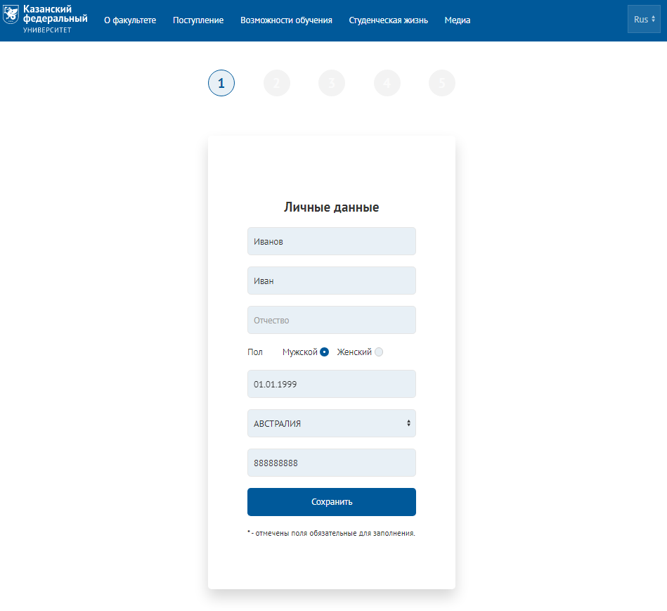

Completing forms

“Personal data” form

This form contains the information that was used upon registration. In case all the data is correct, it is necessary to click the “Save”/«Сохранить» button and pass on to the next form.

In case some data is not correct, modifications can be made in the form and then it is necessary to click the “Save”/«Сохранить» button and pass on to the next form. All the fields in the form are available for editing.



“Questionnaire” form

This form shall be accordingly completed, all the sections marked with an asterisk* being mandatory.

**Please note that an application for a visa for scholarship students is issued by the Ministry. The information you enter in this section is only for informational purposes only.**

Upon completing all the mandatory fields, the user is to click “Save”/«Сохранить» button and pass on to the next form.

“Education” form

The applicant is to enter the information on education into this form.

If the applicant independently completes the form, the option of “Individual application”/ «Индивидуальная заявка» should be chosen in “Additional information”/ «Дополнительная информация» section.

“Files” form

The files should be attached to the forms marked with an asterisk*

One file in pdf-format shall be attached to one form and then the “Save”/«Сохранить» button should be clicked.

If the user has attached a wrong file, it is necessary to click “Delete”/«Удалить» button next to the corresponding form and to attach the required file.

Upon attaching all the mandatory files, the user is to click “Save”/«Сохранить» button and pass on to the next form. The files already approved by the KFU International office shall not be available for editing.

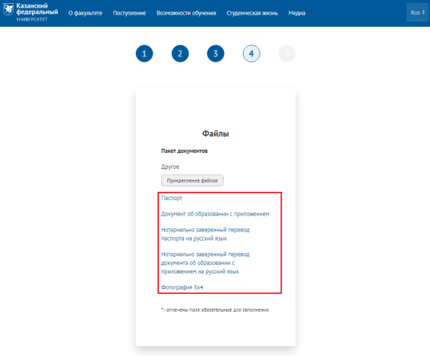

After completing the registration and attaching the package of documents, it is necessary to notify the Dean office of the Preparatory School about the completion of registration by e-mail [preparatorykfu@mail.ru](mailto:preparatorykfu@mail.ru).



Password recovery

To recover the password it is necessary to choose “Forgot password?”/«Забыли пароль?» section in the Authorization form.

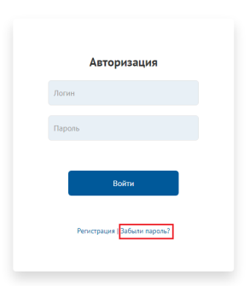

Then it is necessary to enter the e-mail address that was used upon registration and click “Send”/«Отправить» button

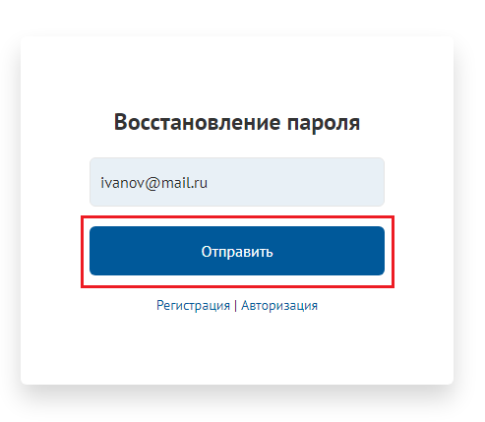

The user is to receive an e-mail from noreply@kpfu.ru with the information on the password recovery upon condition that the indicated e-mail address was previously used for the registration. In case there is no such e-mail in the “Inbox” folder, it is recommended to check “Spam” folder of the e-mail box.

**After registration is completed, you must notify The Preparatory Department by email** [***preparatorykfu@mail.ru***](mailto:preparatorykfu@mail.ru)